The Impact of Intimacy and Collaboration Tendency on Collaborative Behavior

Abstract

Group cooperation of different sizes and organizations requires collaborative information behaviors. Through a user experiment, this paper analyzes five types of behaviors of small-scale groups, including collaborative planning, collaborative information seeking, information sharing, information using and communicating, and explores the impact of intimacy and collaboration tendency of group members on the above behaviors. It is found that groups with high intimacy tend to develop collaborative strategies, arrange schedule and communicate, while groups with low intimacy tend to share information directly and use the information shared by group members directly. Groups with high collaborative tendency tend to develop information use strategies and communicate, while those with low collaborative tendency tend to divide tasks and retrieve information independently, and are more likely to have no response or delayed response in communication. This paper can help us to further understand the influence of intimacy and collaboration tendency of group members on small-scale online knowledge collaboration behavior, as well as the behavior mode of small-scale users' online knowledge collaboration. The research results can be applied to online education, scientific research collaboration and other fields, providing reference for the improvement of online knowledge collaboration tools.

Keywords

Collaborative information behaviors; Group Composition; Intimacy; Collaborative Tendency

# Introduction and literature Review

**Collaborative information behavior**

Collaborative information behavior (CIB) differs from individual information behavior (IIB) in regard to how individuals interact with each other, the complexity of the information need, and the role of information technology(Reddy & Jansen, 2008). A situated model embedded within the organizational context was developed to identify three phases: problem formulation, collaborative information seeking (CIS), and information use. And information sharing and evaluation and collaborative sensemaking (CS) are common to all the phases (Karunakaran, Reddy, & Spence, 2013).

**Collaborative strategies**

A collaborative task consists of two parts, “collaborating alone” (i.e., continuing a search across time or devices) and “collaborating together” (i.e., involve multiple people with different services). Users can be described along two axes when they collaborative alone: “initiative (whether the user was active or passive) and stage (whether the strategy applies to the storage or retrieval of the search context)”. When users collaborative together, they tend to use divide-and-conquer or brute force methods, the former involved explicit coordination and planning, the latter people search separately and results were merged afterwards(Morris, 2007). The divide-and-conquer method can be divided into three types: parallel(i.e., divide the task into subtasks so that all collaborators work at the same time), sequential(i.e., divide the task into successive phases in time and have them done by different collaborators) and reciprocal(i.e., assign tasks to different collaborators and they communicate throughout the process) (Sharples, 1993).

**CIS**

CIS needs to be figured as an information retrieval process(Koschmann & Stahl, 1998), including collaborative planning, collaborative information searching, sharing of information and collaborative decision making(Arif, Jia, & Lee, 2015). Recently several tools (e.g., Knowledge Community(Tan & Chan, 2008), Coagmento(邱瑾 & 吴丹, 2013), Moodle(陈向东, 马金金, 谢三林, & 骆莎, 2008)) has been designed to support awareness and division of labour across collaborators. And these studies often found division of labor and sharing of knowledge is critical for the process of CIS (Foley & Smeaton). Sharing and understanding knowledge effectively is considered one of the foundations of any group activity(Yao, Neches, Ko, Eleish, & Abhinkar, 1999), which also reflect the significance of CS during the process of CIS(Foley & Smeaton, 2010).

**CS**

CS refers to a process in which inquirers with different knowledge backgrounds try to establish a common understanding and form the final external expression(李枫林, 魏蕾如, & 吴敏, 2017).And it usually occurs when there is “ambiguity of available information, role-based distribution of information, and lack of expertise”. To achieve CS, group members need to prioritize the correlation information by the level of sharing need or the understanding of a particular situation. They also need to transfer information between people accurately to form a consistent sensemaking trajectories(Paul & Reddy, 2010). Last but not least, group members must have a holistic awareness of the overall situation, that is, activities awareness, including changes to shared plans and evaluations, and dependencies among different tasks(Carroll, Neale, Isenhour, Rosson, & McCrickard; Paul & Reddy, 2010).

**Intimacy and collaboration tendency**

The method of small-scale user experiment is widely applied to study the influencing factors of CIS and CS of users, such as perception of task, situational awareness, intimacy(袁红 & 赵宇珺), community type(吴丹 & 向雪, 2014), collaborative ability(吴丹 & 邱瑾, 2012), time, task order(杨帆, 2015), task type(Tao & Tombros; 吴丹 & 邱瑾, 2012), etc. Besides, interpersonal emotional intimacy, which(dingyi), was point out important to the cognitive and affective identification with the organization, thus facilitating users’ contributions to collaborative behavior(Gibson, 2018; Sguera, Bagozzi, Huy, Boss, & Boss, 2019). The relationship between two potential factors, intimacy and collaboration tendency, that may affect organizational identification and collaborative information behavior will be tested in the following research.

# Research design and methodology

**Participants**

The participants in the research study were 24 students form Information Management Department of Peking University, including 18 female and 6 male. Using the scores of the Thinking Style Inventory(戴晓阳, 2010) in recruitment questionnaire, the participants were divided into four high collaborative tendency and four low collaborative tendency three-person group. All participants were experienced in information seeking and had participated in group cooperative tasks.

**Project assignments**

The participants were required to complete two tasks at least one day apart from each other. Taking one of the tasks as an example, the details and requirements are as follows:

*Internet hospital is a new application of the internet in medical industry, including online health instruction, health information inquiry, disease consultation and so on. As a representative of the future medical hospital, Internet hospital, which has been actively guided and supported by the ministry of health, is conducive to solving the contradiction between the imbalance of medical resources in China and the increasing demand for health care.*

*1. Please find the establishment time, initiator, important time nodes and events in the development process of Wuzhen Internet hospital.*

*2. Please sort out the differences between the main service modes of Wuzhen Internet hospitals (such as registration, inquiry, payment, prescription issuing, medical distribution, personal health management, etc.) and traditional hospitals.*

*Your group has to prepare a 10-15 minute presentation on the topic of Internet hospital in 45 minutes.*

**Procedure**

Firstly, the intimacy of members in the group was measured by the Relationship Closeness Inventory (Berscheid, Snyder, & Omoto, 1989). And the following table provides an overview of each group’s intimacy and collaborative tendency. There are two of each type of group: high collaborative tendency and high intimacy, high collaborative tendency and low intimacy, low collaborative tendency and high intimacy, low collaborative tendency and low intimacy.

|  |  |  |
| --- | --- | --- |
| Group | Collaborative Tendency | Intimacy |
| A | Low | High |
| B | High | High |
| C | Low | Low |
| D | High | Low |
| E | Low | Low |
| F | High | High |
| G | High | Low |
| H | Low | High |

Before the task, the participants will be introduced the experimental requirements and provided 10 minutes to familiarize with the operation of Youdao cloud. And all the collaboration among the team members needs to be completed in the Youdao cloud. During the task all group has two tasks and the task order of the two groups of each type was different to eliminate the interference of task order on the results. Each group was given 45 minutes to complete a task, after which the experiment had to be finished whether or not it had been completed. At the end of each task, the participants were asked to give a brief interview about the group's collaborative strategies. During the period, the participants need to use a computer with a user research software, Morea, communicate and collaborate through a collaboration software, Youdao cloud. Any search method can be used during the process, and the final results are edited in the Youdao cloud.

# Data analysis

## Coding system of collaborative information behaviors

On the basis of the grounded theory, six videos of two tasks in group A were selected to complete descriptive coding of participants' behavior, communication content and interview records. The concept in descriptive coding was classified to construct the behavior framework, coding system and coding standard basing on current theories in the research field of collaborative information behavior. If new behavior classification was found in the subsequent coding process, they will be added to the behavior framework and coding system and the previous coding will be updated. Through the coding of 48 videos, it is found that the small-scale online collaboration mainly includes five types of behaviors: collaborative planning, collaborative information seeking, information sharing, information using and communicating.

|  | Code | Behaviors | Code | Behaviors | Details |
| --- | --- | --- | --- | --- | --- |
| Collaborative Planning | P1 | Develop Strategies | P11 | Develop collaborative strategies | Rules on how team members collaborate |
| P12 | Develop information seeking strategies | Rules on how team members use retrieval tools and sources |
| P13 | Develop information sharing strategies | Rules on the means and frequency of sharing information |
| P14 | Develop information using strategies | Rules on how team members use information |
| P15 | Develop integration strategies | Rules on how to integrate the work of different members |
| P2 | Division of tasks | | | Break the task down into small and actionable tasks |
| P3 | Division of labor | | | Division of labor for small tasks after the breakdown |
| P4 | Arrange schedule | | | Schedule completion times for each task |
| Collaborative Information Seeking | Q1 | Select retrieval tool | | |  |
| Q2 | Independent information retrieval | Q21 | Input retrieval term |  |
| Q22 | Source of retrieval term | Directly input/reference other’s retrieval words/system recommended words |
| Q23 | Content of retrieval term |  |
| Q24 | Click on the URL |  |
| Q25 | The type of URL being clicked on | Encyclopedias, news, articles, websites, knowledge communities, blogs |
| Q3 | Help others retrieve information | Q31 | Input retrieval term |  |
| Q32 | Source of retrieval term |  |
| Q33 | Content of retrieval term | Directly input/reference other’s retrieval words/system recommended words |
| Q34 | Click on the URL |  |
| Q35 | The type of URL being clicked on | Encyclopedias, news, articles, websites, knowledge communities, blogs |
| Information Sharing | L1 | Share information seeking strategies | L11 | Share retrieval tool |  |
| L12 | Share retrieval experience |  |
| L13 | Share background knowledge |  |
| L2 | Share content of information seeking | L21 | Share retrieval term |  |
| L22 | Share retrieval content |  |
| L23 | Share URL |  |
| L24 | Share relevant information |  |
| L3 | View group records | L31 | View chat history |  |
| L32 | View operation history |  |
| L33 | View history notifications |  |
| Information Using | U1 | Edit personal results | | |  |
| U2 | Using information shared by group members | U21 | Using retrieval tools shared by group members |  |
| U22 | Using retrieval words shared by group members |  |
| U23 | Click on the URL shared by group members |  |
| U24 | View the information shared by group members |  |
| U3 | Using group results | U31 | View group results |  |
| U32 | Integrate group result |  |
| U33 | Edit group results |  |
| Communicating | C1 | Speaking to group members | | |  |
| C2 | Determine means of communication | | |  |
| C3 | Conflict of decision making occurs | | |  |
| C4 | Conflict of decision making solved | | |  |
| C5 | No response/response delayed | | |  |

## Descriptive statistics of coding

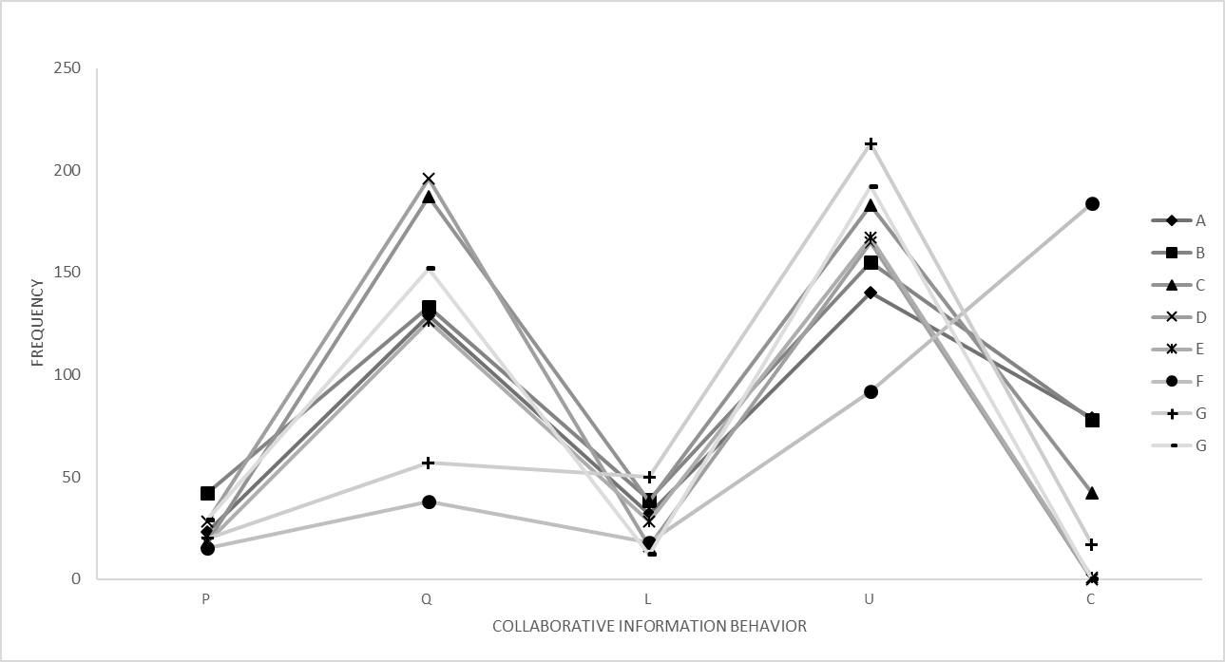

As can be seen above, the frequency of Information Using behavior (1307 times) is the most, followed by the Collaborative Information Seeking (1018 times), and the frequency of collaborative planning (193 times) is the least.

## The influence of intimacy and collaborative tendency on the collaborative information behavior

Since the collected samples did not conform the hypothesis of normal distribution, a Non-parametric test, Mann-Whitney test, was adopted to analyze collaborative information behavior of the participants under different degrees of intimacy and collaborative tendency.

**The influence of intimacy on the collaborative information behavior**

|  |  |  |  |  |  |
| --- | --- | --- | --- | --- | --- |
|  | Mann Whitney U test | Z scores | Asymp. Sig.(2-tailed) | Exact. Sig.(2-tailed) | Exact. Sig.(1-tailed) |
| P1 Develop Strategies | 175 | -2.397 | 0.017 | 0.016 | 0.008 |
| P14 Develop information using strategies | 192 | -3.056 | 0.002 | 0.004 | 0.002 |
| P4 Arrange schedule | 173.5 | -2.615 | 0.009 | 0.010 | 0.005 |
| L24 Share relevant information | 181.5 | -2.698 | 0.007 | 0.010 | 0.005 |
| U Information Using | 207 | -1.672 | 0.095 | 0.096 | 0.048 |
| U24 View the information shared by group members | 206.5 | -1.94 | 0.052 | 0.054 | 0.027 |
| C Communicating | 112 | -3.748 | 0.000 | 0.000 | 0.000 |
| C1 Speaking to group members | 199 | -2.05 | 0.040 | 0.040 | 0.020 |
| C2 Determine means of communication | 216 | -2.584 | 0.010 | 0.022 | 0.011 |
| C3 Conflict of decision making occurs | 204 | -2.821 | 0.005 | 0.009 | 0.005 |

Intimacy has a significant influence on P1(develop strategies, p=0.017), P14(develop information using strategies, p=0.002), P4(arrange schedule, p=0.01), L24(share relevant information, p=0.01), U(information using, p=0.048, one-tailed), U24(view the information shared by group members, p=0.027, one-tailed), C(communicating, p<0.0001), C1(speaking to group members, p=0.04), C2(determine means of communication, p=0.01), C3(conflict of decision making occurs, p=0.005).

The frequency of P1(develop strategies, p=0.008, one-tailed), P14(develop information using strategies, p=0.002, one-tailed), P4(arrange schedule, p=0.005, one-tailed), C(communicating, p<0.0001), C1(speaking to group members, p=0.02, one-tailed) and C2(determine means of communication, p=0.011, one-tailed) in the group with high intimacy was significantly higher than that in the group with low intimacy. And the frequency of L24(share relevant information, p=0.005, one-tailed), U(information using, p=0.048, one-tailed) and U24(view the information shared by group members, p=0.027, one-tailed) in the group with high intimacy was significantly lower than that in the group with low intimacy.

|  |  |  |  |  |  |
| --- | --- | --- | --- | --- | --- |
|  | Mann Whitney U test | Z scores | Asymp. Sig.(2-tailed) | Exact. Sig.(2-tailed) | Exact. Sig.(1-tailed) |
| L24 Share relevant information | 35 | -2.574 | 0.01 | 0.021 | 0.01 |
| C1 Speaking to group members | 39.5 | -2.338 | 0.019 | 0.023 | 0.011 |

Among the groups with high collaborative tendency, the frequency of C1(speaking to group members, p=0.011, one-tailed) in the group with high intimacy was higher than that of the group with low intimacy, while the frequency of L24(share relevant information, p=0.01, one-tailed) in the group with high intimacy was lower than that of the group with low intimacy.

|  |  |  |  |  |  |
| --- | --- | --- | --- | --- | --- |
|  | Mann Whitney U test | Z scores | Asymp. Sig.(2-tailed) | Exact. Sig.(2-tailed) | Exact. Sig.(1-tailed) |
| P1 Develop Strategies | 41 | -1.845 | 0.065 | 0.074 | 0.037 |
| P14 Develop information using strategies | 30 | -3.04 | 0.002 | 0.005 | 0.002 |
| P4 Arrange schedule | 38 | -2.271 | 0.023 | 0.032 | 0.016 |
| U Information Using | 41 | -1.793 | 0.073 | 0.075 | 0.037 |
| C Communicating | 2.5 | -4.033 | 0 | 0 | 0 |

Among the groups with low collaborative tendency, the frequency of P1(develop strategies, p=0.037, one-tailed), P14(develop information using strategies, p=0.002, one-tailed), P4(arrange schedule, p=0.016, one-tailed) and C(communicating, p<0.0001, one-tailed) in the group with high intimacy was higher than that of the group with low intimacy, while the frequency of U(information using, p=0.037, one-tailed) in the group with high intimacy was lower than that of the group with low intimacy.

**The influence of collaborative tendency on the frequency of collaborative information behavior**

|  |  |  |  |  |  |
| --- | --- | --- | --- | --- | --- |
|  | Mann Whitney U test | Z scores | Asymp. Sig.(2-tailed) | Exact. Sig.(2-tailed) | Exact. Sig.(1-tailed) |
| P14 Develop information using strategies | 215 | -2.324 | 0.02 | 0.037 | 0.018 |
| P2 Division of tasks | 207 | -1.872 | 0.061 | 0.076 | 0.038 |
| Q Collaborative Information Seeking | 192.5 | -1.971 | 0.049 | 0.049 | 0.024 |
| Q2 Independent information retrieval | 203.5 | -1.745 | 0.081 | 0.082 | 0.041 |
| Q21 Input retrieval term | 112 | -3.656 | 0 | 0 | 0 |
| U31 View group results | 196 | -1.946 | 0.052 | 0.052 | 0.026 |
| C Communicating | 210 | -1.661 | 0.097 | 0.098 | 0.049 |
| C2 Determine means of communication | 216 | -2.584 | 0.01 | 0.022 | 0.011 |
| C3 Conflict of decision making occurs | 204 | -2.821 | 0.005 | 0.009 | 0.005 |
| C5 No response/response delayed | 228 | -2.334 | 0.02 | 0.05 | 0.025 |

Collaborative tendency has a significant influence on P14(develop information using strategies, p=0.02), P2(division of tasks, p=0.038, one-tailed), Q(collaborative information seeking, p=0.049), Q2(independent information retrieval, p=0.041, one-tailed), Q21(input retrieval term, p<0.0001), U31(view group results, p=0.026, one-tailed), C(communicating, p=0.049, one-tailed), C2(determine means of communication, p=0.01), C3(conflict of decision making occurs, p=0.005), C5(no response/response delayed, p=0.02).

The frequency of P14(develop information using strategies, p=0.018, one-tailed), C(communicating, p=0.049, one-tailed), C2(determine means of communication, p=0.011, one-tailed) and C3(conflict of decision making occurs, p=0.005, one-tailed) in the group with high collaborative tendency was significantly higher than that in the group with low collaborative tendency. And the frequency of P2(division of tasks, p=0.038, one-tailed), Q(collaborative information seeking, p=0.024, one-tailed), Q2(independent information retrieval, p=0.041, one-tailed), Q21(input retrieval term, p<0.0001), U31(View group results, p=0.026, one-tailed) and C5(No response/response delayed, p=0.025, one-tailed) in the group with high collaborative tendency was significantly lower than that in the group with low collaborative tendency.

|  |  |  |  |  |  |
| --- | --- | --- | --- | --- | --- |
|  | Mann Whitney U test | Z scores | Asymp. Sig.(2-tailed) | Exact. Sig.(2-tailed) | Exact. Sig.(1-tailed) |
| P14 Develop information using strategies | 35 | -2.574 | 0.01 | 0.021 | 0.01 |
| Q Collaborative Information Seeking | 35 | -2.138 | 0.033 | 0.032 | 0.016 |
| Q2 Independent information retrieval | 32.5 | -2.283 | 0.022 | 0.021 | 0.011 |
| C Communicating | 17.5 | -3.174 | 0.002 | 0.001 | 0 |
| C2 Determine means of communication | 36 | -2.732 | 0.006 | 0.014 | 0.007 |
| C3 Conflict of decision making occurs | 30 | -3.019 | 0.003 | 0.005 | 0.002 |

Among the groups with high intimacy, the frequency of P14(develop information using strategies, p=0.01, one-tailed), C(communicating, p<0.0001, one-tailed), C2(determine means of communication, p=0.007, one-tailed) and C3(conflict of decision making occurs, p=0.002, one-tailed) in the group with high collaborative tendency was higher than that of the group with low collaborative tendency, while the frequency of Q(collaborative information seeking, p=0.016, one-tailed) and Q2(independent information retrieval, p=0.011, one-tailed) in the group with high collaborative tendency was lower than that of the group with low collaborative tendency.

|  |  |  |  |  |  |
| --- | --- | --- | --- | --- | --- |
|  | Mann Whitney U test | Z scores | Asymp. Sig.(2-tailed) | Exact. Sig.(2-tailed) | Exact. Sig.(1-tailed) |
| P2 Division of tasks | 32 | -2.534 | 0.011 | 0.011 | 0.006 |
| Q21 Input retrieval term | 11.5 | -3.52 | 0 | 0 | 0 |
| U31 View group results | 43.5 | -1.679 | 0.093 | 0.098 | 0.049 |

Among the groups with low intimacy, the frequency of P2(division of tasks, p=0.006, one-tailed) in the group with high collaborative tendency was higher than that of the group with low collaborative tendency, while the frequency of Q21(input retrieval term, p<0.0001) and U31(View group results, p=0.049, one-tailed) in the group with high collaborative tendency was lower than that of the group with low collaborative tendency.

## Analysis of online knowledge collaboration mode for small-scale users

Among all the knowledge collaboration behaviors of users, collaboration planning, information retrieval for others, information sharing, editing group achievements and speaking times are categories that can reflect the degree of group collaboration. Through the analysis of the above categories of data and the observation of the experimental process, our study found that online knowledge collaboration of small-scale users has a fixed mode, which can be divided according to the division of labor, and the task collaboration strategy of the group.

|  |  |  |  |  |  |  |  |  |  |
| --- | --- | --- | --- | --- | --- | --- | --- | --- | --- |
| Type of behaviors | Group members | Close collaboration under leadership | | Division of labor under leadership | | Spontaneous division of labor and collaboration | | | |
| C组 | G组 | D组 | E组 | A组 | B组 | F组 | H组 |
| P Collaborative Planning | Total frequency | 18 | 20 | 28 | 18 | 23 | 42 | 15 | 29 |
| Group leader/Group member 1 | 3 | 6 | 15 | 13 | 8 | 20 | 7 | 8 |
| Group member 2 | 9 | 2 | 9 | 1 | 7 | 11 | 5 | 9 |
| Group member 3 | 6 | 12 | 4 | 4 | 8 | 11 | 3 | 12 |
| L1 Share information seeking strategies | Total frequency | 5 | 1 | 1 | 1 | 9 | 4 | 1 | 0 |
| Group leader/Group member 1 | 0 | 0 | 1 | 1 | 5 | 1 | 0 | 0 |
| Group member 2 | 0 | 1 | 0 | 0 | 2 | 1 | 0 | 0 |
| Group member 3 | 5 | 0 | 0 | 0 | 2 | 2 | 1 | 0 |
| L2 Share content of information seeking | Total frequency | 5 | 10 | 6 | 8 | 5 | 7 | 8 | 5 |
| Group leader/Group member 1 | 4 | 3 | 5 | 2 | 3 | 2 | 7 | 1 |
| Group member 2 | 1 | 3 | 0 | 1 | 0 | 5 | 0 | 2 |
| Group member 3 | 0 | 4 | 1 | 5 | 2 | 0 | 1 | 2 |
| Q3 Help others retrieve information | Total frequency | 13 | 3 | 0 | 17 | 19 | 9 | 2 | 12 |
| Group leader/Group member 1 | 9 | 0 | 0 | 0 | 1 | 0 | 0 | 15 |
| Group member 2 | 4 | 6 | 0 | 0 | 5 | 0 | 0 | 0 |
| Group member 3 | 0 | 0 | 0 | 17 | 13 | 12 | 1 | 6 |
| U3 Using group results | Total frequency | 43 | 63 | 99 | 84 | 71 | 45 | 119 | 122 |
| Group leader/Group member 1 | 11 | 20 | 48 | 47 | 42 | 16 | 65 | 45 |
| Group member 2 | 6 | 13 | 39 | 21 | 11 | 12 | 26 | 36 |
| Group member 3 | 26 | 30 | 12 | 16 | 18 | 17 | 28 | 41 |
| C1 Speaking to group members | Total frequency | 42 | 7 | 0 | 1 | 79 | 76 | 0 | 0 |
| Group leader/Group member 1 | 15 | 7 | 0 | 1 | 37 | 24 | 0 | 0 |
| Group member 2 | 13 | 0 | 0 | 0 | 22 | 23 | 0 | 0 |
| Group member 3 | 14 | 0 | 0 | 0 | 20 | 31 | 0 | 0 |

### The mode of collaboration

Through the qualitative analysis of team members' behaviors and the quantitative analysis of video encoding data, the mode of collaboration can be divided into three types: close collaboration under leadership, division of labor under leadership, and spontaneous division of labor and collaboration. The quantitative data division of each type is shown in table 4.5.

**(1) Close collaboration under leadership**

In the group with leadership and close collaboration, one group member acts as the leader to lead the collaborative process spontaneously, and other group members actively participate in the collaboration under the leader's leadership. There are many group interactions and exchanges, and the collaboration efficiency is high. The typical group with leadership and close collaboration include group C with low intimacy and weak collaboration and group G with low intimacy and strong collaboration.

**(2) Division of labor under leadership**

Similar to the last type, a group with leadership and close collaboration also has a group member acting as the team leader spontaneously, and the team leader leads the task decomposition, but has relatively less interaction with the group members, and completes the tasks after the division. Among them, information sharing behavior, editing group achievement behavior and communication behavior are significantly less than the last group. The typical groups with leadership and close collaboration include group D with low intimacy and strong collaboration and group E with low intimacy and weak collaboration.

**(3) Spontaneous division of labor and collaboration**

There is no obvious group leader in the group, and each group member actively speaks and interacts with each other to formulate collaboration strategies together. In addition to completing their own tasks, they will also help team members to carry out information retrieval and results editing, actively share task-related information, maintain continuous attention to task progress, and finally work together to integrate results. The typical groups with spontaneous division of labor and collaboration include group B and group F with high intimacy and strong collaboration, and group A and group H with high intimacy and weak collaboration.

It can be seen that intimacy has a great impact on the type of collaboration and division of labor the group. The group with low affinity density is more likely to produce a task collaboration mode led by the team leader, while the group with high intimacy is more likely to a collaboration and division of labor mode.

### The collaboration strategy of the task

There are four types: parallel type, parallel-sequence type, reciprocal type and parallel- reciprocal type.

**(1) Parallel**

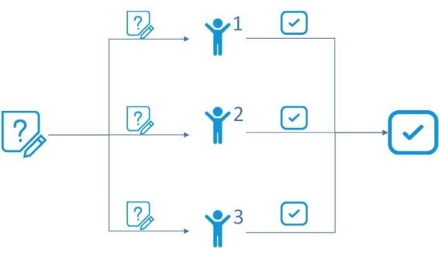

Parallel group refers to decomposing tasks into sub tasks at the beginning of tasks. Team members work at the same time with high efficiency, but the level of interaction within the group is low. When summarizing, it is only a simple combination of the results of team members. Except for group F, the first task of other groups was parallel strategy. Because the parallel strategy highly depends on the execution of team members, it will also have a negative impact on the task. For example, in the first task of group E, although team member E-2 is arranged by the division of labor within the group, he did not complete the task according to the division of labor, and did not upload his own results to the group file folder, and did not contribute to this collaboration.

**(2) Parallel-sequential**

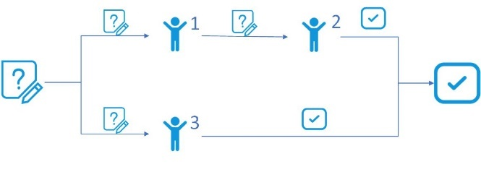

It refers to that after tasks are divided according to the parallel type, there is a sequence relationship in some subtasks. Therefore, at the beginning of the task, the tasks of one team member are divided into phases, and the task results of one team member are output and then transferred to the next team member for further completion or as the basis for the next team member to complete the task. For example, in the second task of group D, in the process of finding materials, group leader D-1 first finds three disputed points and then passes them to group member D-2 to find corresponding solutions. The advantage of sequential collaboration strategy is that it fully considers the sequential logical relationship between tasks when decomposing tasks, which makes the final task results close and logical, and the interaction between team members strong. The disadvantage is that it may cause a certain degree of time waste and human resources idle.

**(3) Reciprocal**

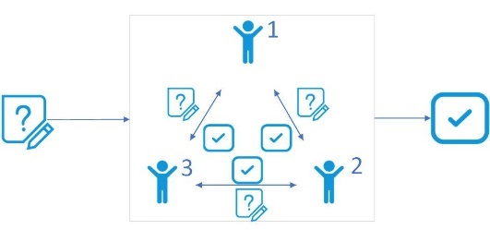

Reciprocal group refers to the type of group members who read materials, search information and edit results without division of labor. The advantage of this strategy is that each group member has a comprehensive understanding of the group task, and the group can communicate fully and edit the group results together. The disadvantage of this strategy is that it may lead to low efficiency and some group members may be separated from the collaboration. For example, in the second task of group C, the group member C-3 searched for information and read relevant materials and shared information some time ago. He did not participate in the first question answering. In the second question, he added a very small sub question. His direct contribution to the results of the group was much lower than that of the other two members.

**(4) Parallel- reciprocal**

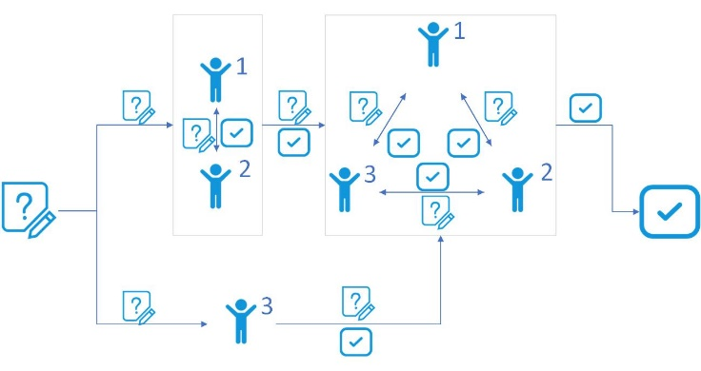

Parallel response group refers to a group that has both division of labor and collaboration. There are two situations in the experiment, one is that two members are responsible for the same problem, the other is that one member joins in the collaboration of the other two members after finishing his own part. Parallel collaborative strategy focuses on the advantages and disadvantages of parallel and collaborative strategies. It not only clarifies the task division, but also ensures the team members' overall grasp of the group tasks and the degree of group interaction, and makes full use of human resources. However, there may be cases where individual team members make less contribution to small composition.

In general, the first task of the eight groups used parallel collaboration strategy (except for the F group with high affinity and weak collaboration using response and parallel collaboration strategies, the other groups only used parallel strategy). Five groups in the second task carried out the evolution of collaboration strategy. Group A with high affinity and strong collaboration, group B with high affinity and weak collaboration and group H with low affinity and weak collaboration were adjusted to parallel response strategy. Group C with low affinity and strong collaboration was adjusted to response strategy. Group D with low affinity and weak collaboration was adjusted to parallel sequence strategy. And groups E, F and G were not adjusted, still parallel. Therefore, affinity density and collaboration tendency have no significant effect on collaboration strategies and changes.

# Discussion

Through the quantitative and qualitative analysis of the video of user experiments, it was found that the small-scale online knowledge collaboration of users mainly includes five types of collaborative behaviors: collaborative planning, collaborative information seeking, information sharing, information using and communicating. A coding framework was established to manually encode 720 minutes of experimental videos of 16 tasks of 8 groups. Information using can be found the most frequent behaviors of participants by the analyzing the frequency of each type of behavior, which followed closely by collaborative information seeking. And the collaborative planning behaviors has the lowest frequency. Group B with high intimacy and high collaborative tendency has the highest frequency of collaborative behaviors, followed by group C with low intimacy and low collaborative tendency. Group E with low intimacy and low collaborative tendency has the lowest frequency, while group G with low intimacy and high collaborative tendency has the second lowest frequency.

SPSS22.0 was used to conduct the non-parametric test (Man-Whitney U test) of two independent samples on the coding results to explore the influence of intimacy and collaborative tendency on small-scale online knowledge collaboration. It is found that groups with high intimacy tend to develop collaborative strategies, arrange schedule and communicate, while groups with low intimacy tend to share information directly and use the information shared by group members. Groups with low intimacy and high collaborative tendency have a preference to share the related information. In the case of low collaborative tendency, groups with high intimacy are more likely to develop group strategies and arrange schedule, while groups with low intimacy are more likely to use information directly. Groups with high collaborative tendency tend to develop information use strategies and communicate, while those with low collaborative tendency tend to divide tasks and retrieve information independently, and are more likely to have no response or delayed response in communication. In the case of high intimacy, groups with high collaborative tendency are more likely to specify group strategies and communicate, while groups with low collaborative tendency are more likely to search independently. In the case of low intimacy, groups with high collaborative tendency tend to divide the tasks, while groups with low collaborative tendency tend to look directly at the results of other group members.

The mode of collaboration of can be divided into three types: close collaboration under leadership, division of labor under leadership, and spontaneous division of labor and collaboration. The main difference between the first two types of groups is that the former are more collaborative. Groups with low intimacy tend to have a leader who leads the group in task coordination. Groups with high intimacy are usually a cooperative group with no leader and have good cooperation among group members. However, the tendency of cooperation does not obviously affect the type of division of labor. The collaboration strategies of the group can be divided into parallel, sequential, reciprocal and parallel- reciprocal. The parallel group has a clear division of tasks, and the members work at the same time so that the team was efficient. However, there is a disadvantage that the team members' degree of cooperation and cognition of the group's overall task are relatively low. Sequential group carries out its task in stages. There is a sequential relationship between the work of team members, which leads to a higher degree of group collaboration and more logical group results, but there is the possibility of idle time and human resources waste. There is no obvious division of labor in the reciprocal group. The team members edit the team's achievements together so that the degree of cooperation is high. Parallel - reciprocal group is a combination of parallel type and reciprocal type, reconciling the advantages and disadvantages of the two. Intimacy and collaborative tendency have no significant effect on collaboration strategies.

# Conclusion

There are some limitations in this study due to the experimental design and software:

**Experimental Design**

Although the experiment strictly controled the intimacy, collaborative tendency and knowledge background of participants, it had not balance the ratio of male to female, educational level, which may affect the experimental results to some extent. And there are only two group samples for each type of experimental group. The small sample size may affect the experimental results due to individual differences, and the universality of the research conclusion is problematic.

**Software**

Although the team is required to use knowledge collaboration software, YouDao cloud, for the convenience of observation and data collection, the use of software itself has still caused some obstacles to the collaboration. The message notification of YouDao cloud is not timely, because the new message notification are only inside the YouDao cloud, you won't see them outside the particular web, therefore the communication for group member has certain hysteresis. And due to the poor stability of the user research software Morae, the second task data of group H could not be read in the experiment. In order to retrieve the data, we had to recontact the three members of group H for the second experiment.

The future study can explore the impact on the quality of small-scale knowledge collaboration results of intimacy, collaborative tendency of group members. From the perspective of the research object, future research can further expand the sample sizes and conduct relevant research on large-scale online knowledge collaboration. From the perspective of research methods, a website or mobile App can be taken as an platform to conduct research by using quantitative research method such as log method and qualitative research methods such as questionnaire method and interview method.

# References

Arif, A. S. M., Jia, T. D., & Lee, I. (2015). Understanding tourists' collaborative information retrieval behavior to inform design. *Journal of the Association for Information Science & Technology, 66*(11), 2285–2303.

Berscheid, E., Snyder, M., & Omoto, A. M. (1989). The relationship closeness inventory: Assessing the closeness of interpersonal relationships. *Journal of personality and Social Psychology, 57*(5), 792.

Carroll, J. M., Neale, D. C., Isenhour, P. L., Rosson, M. B., & McCrickard, D. S. Notification and awareness: synchronizing task-oriented collaborative activity. *International Journal of Human-Computer Studies, 58*(5), 605-632.

Foley, C., & Smeaton, A. F. Division of labour and sharing of knowledge for synchronous collaborative information retrieval. *Information Processing & Management, 46*(6), p.762-772.

Foley, C., & Smeaton, A. F. (2010). Division of labour and sharing of knowledge for synchronous collaborative information retrieval. *Information Processing & Management, 46*(6), 762-772.

Gibson, K. R. (2018). Can I tell you something? How disruptive self-disclosure changes who “we” are. *Academy of Management Review, 43*(4), 570-589.

Karunakaran, A., Reddy, M. C., & Spence, P. R. (2013). Toward a Model of Collaborative Information Behavior in Organizations. *Journal of the American Society for Information Science & Technology, 64*(12), 2437-2451.

Koschmann, T., & Stahl, G. (1998). *Learning issues in problem-based learning: Situating collaborative information seeking.* Paper presented at the Conference on computer supported cooperative work.

Morris, M. R. (2007). *Collaborating alone and together: Investigating persistent and multi-user web search activities.* Paper presented at the Proceedings of International ACM SIGIR Conference on Research and Development in Information Retrieval (SIGIR 2007). Amsterdam, Netherland: ACM.

Paul, S. A., & Reddy, M. C. (2010). *Understanding together: Sensemaking in collaborative information seeking.* Paper presented at the Acm Conference on Computer Supported Cooperative Work.

Reddy, M. C., & Jansen, B. J. (2008). A model for understanding collaborative information behavior in context: A study of two healthcare teams. *Information Processing & Management, 44*(1), 256-273.

Sguera, F., Bagozzi, R. P., Huy, Q. N., Boss, R. W., & Boss, D. S. (2019). What We Share Is Who We Are and What We Do: How Emotional Intimacy Shapes Organizational Identification and Collaborative Behaviors. *Applied Psychology*.

Sharples, M. (1993). *Adding a Little Structure to Collaborative Writing*: Springer London.

Tan, C., & Chan, Y. Y. (2008). Knowledge Community: A Knowledge-Building System for Global Collaborative Project Learning. *Proceedings of the IEEE, 96*(6), 1049-1061.

Tao, Y., & Tombros, A. How collaborators make sense of tasks together: A comparative analysis of collaborative sensemaking behavior in collaborative information-seeking tasks. *Journal of the Association for Information Science & Technology*, n/a-n/a.

Yao, K. T., Neches, R., Ko, I. Y., Eleish, R., & Abhinkar, S. (1999). *Synchronous and asynchronous collaborative information space analysis tools.* Paper presented at the International Workshops on Parallel Processing.

陈向东, 马金金, 谢三林, & 骆莎. (2008). 在线知识交流协作状况的个案研究. *情报理论与实践, 31*(2), 263-266.

戴晓阳. (2010). 常用心理评估量表手册. *北 京: 人 民 军 医 出 版 社*.

李枫林, 魏蕾如, & 吴敏. (2017). 协同信息查询中的合作意义构建研究. *情报理论与实践, 40*(2), 80-85.

邱瑾, & 吴丹. (2013). 协同信息检索行为中的情感研究. *图书与情报*(2), 105-110.

吴丹, & 邱瑾. (2012). 用户协同信息检索行为与系统评价研究——以任务类型和协同能力为视角. *现代图书情报技术, G354*(9), 62-68.

吴丹, & 向雪. (2014). 社群环境下的协同信息检索行为实验研究. *数据分析与知识发现, 30*(12).

杨帆, 刘. 赵. (2015). 信息检索用户实验设计中时间限制和任务次序的影响研究. *图书情报工作*(1).

袁红, & 赵宇珺. 协同搜索行为中的用户任务感知及情绪状态研究. *图书情报工作, v.59;No.534*(17), 91-100.

